**Ex. No : 4 C**

**Date : 20.03.2025**

**Develop client-side application using React API**

**B. Application demonstrating SASS**

**AIM:**

To Develop application to demonstrate styling using Syntactically Awesome Style Sheets in a react application.

**PROCEDURE:**

|  |  |  |
| --- | --- | --- |
| **S.NO** | **React** | **DESCRIPTION** |
| **1** | **useState()** | **Manages state inside a functional component (e.g., storing form data).** |
| **2** | **useEffect()** | **Runs side effects (e.g., fetching data, form validation on load).** |
| **3** | **onChange()** | **Handles user input changes in form fields.** |
| **4** | **onSubmit()** | **Triggers form submission and validation logic.** |
| **5** | **setState()** | **Updates the state of the component dynamically.** |
| **6.** | **preventDefault()** | **Prevents the default form submission behavior.** |
| **7** | **map()** | **Loops through an array (e.g., displaying validation errors).** |
| **8** | **lighten($color, $amount)** | **Makes a color lighter** |
| **9** | **mix($color1, $color2, $weight)** | **mix(#3498db, #2ecc71, 50%)** |

**SOURCE CODE :**

App.js

import React, { useState } from "react";

import "../styles/todo.scss";

export default function TodoList() {

const [tasks, setTasks] = useState(["Learn Sass", "Build React App"]);

const [input, setInput] = useState("");

const addTask = () => {

if (input.trim()) {

setTasks([...tasks, input]);

setInput("");

}

};

const deleteTask = (index) => {

setTasks(tasks.filter((_, i) => i !== index));

};

return (

<div className="todo-container">

<h1>To-Do List</h1>

<input

type="text"

value={input}

onChange={(e) => setInput(e.target.value)}

placeholder="New task..."

/>

<button onClick={addTask}>Add Task</button>

<ul>

{tasks.map((task, index) => (

<li key={index}>

{task} <button onClick={() => deleteTask(index)}>Delete</button>

</li>

))}

</ul>

</div>

);

}

_variables.sass

$primary-color: #3498db;

$secondary-color: #2ecc71;

$font-stack: "Arial, sans-serif";

_mixins.sass

@mixin *button-styles* {

  padding: 10px 15px;

  border: none;

  cursor: pointer;

  font-size: 16px;

}

Todo.sass:

@import "./variables";

@import "./mixins";

.todo-container {

max-width: 400px;

margin: 50px auto;

font-family: $font-stack;

h1 {

color: $primary-color;

text-align: center;

}

ul {

list-style: none;

padding: 0;

li {

display: flex;

justify-content: space-between;

background: #f4f4f4;

margin: 5px 0;

padding: 10px;

border-radius: 5px;

button {

@include button-styles;

background: $secondary-color;

color: white;

}

}

}

}

**OUTPUT 1 :**

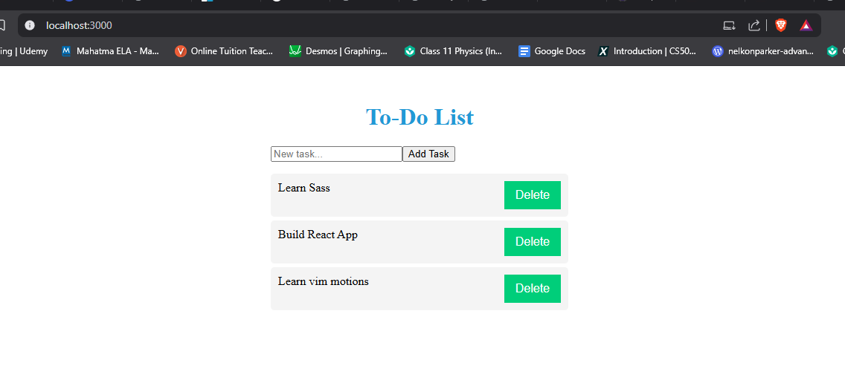

**RESULT :**

The program has been successfully executed and the output is verified.